**Model Development Phase Template**

|  |  |
| --- | --- |
| Date | 15 July 2024 |
| Team ID | xxxxxx |
| Project Title | Early Prediction of Chronic Kidney Disease |
| Maximum Marks | 4 Marks |

**Initial Model Training Code, Model Validation and Evaluation Report**

The initial model training code will be showcased in the future through a screenshot. The model validation and evaluation report will include classification reports, accuracy, and confusion matrices for multiple models, presented through respective screenshots.

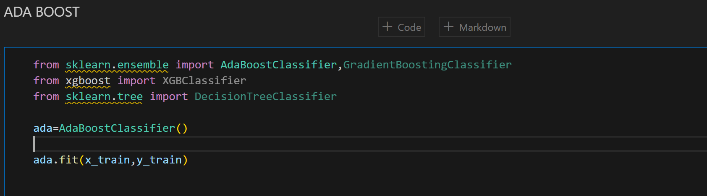

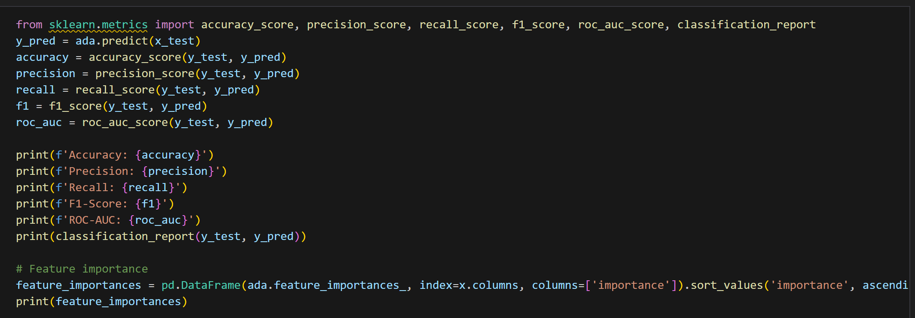

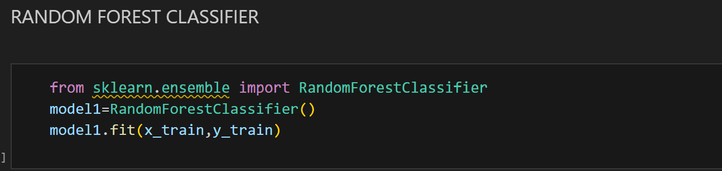

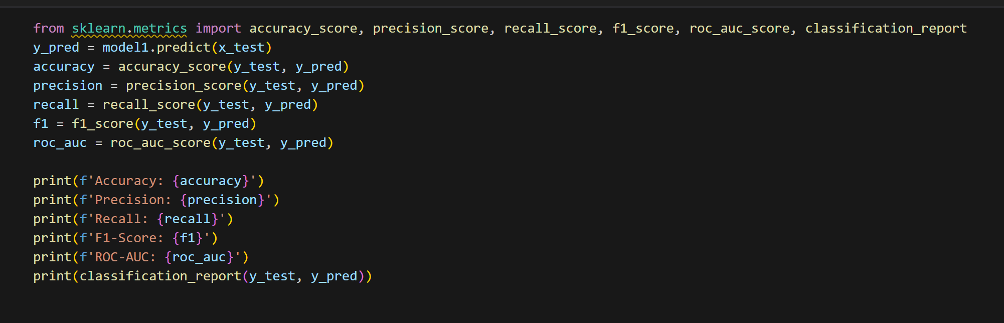

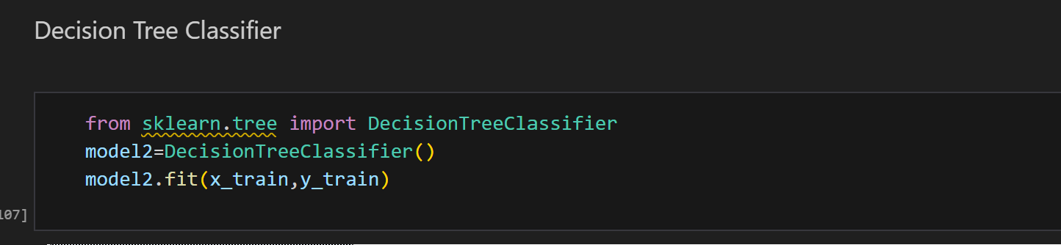

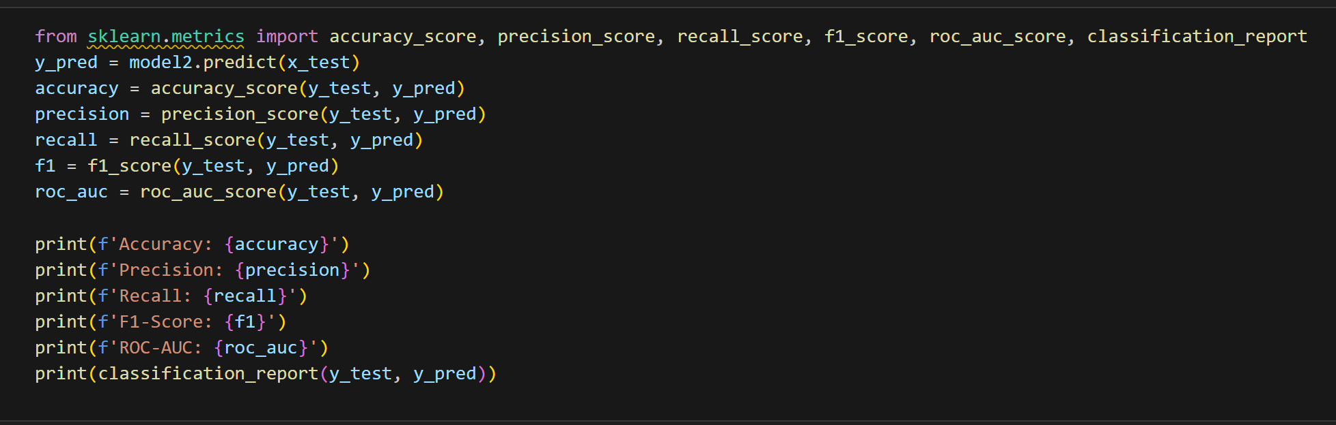

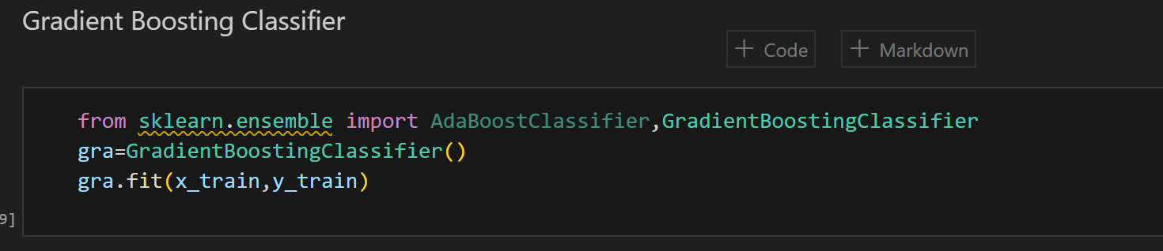

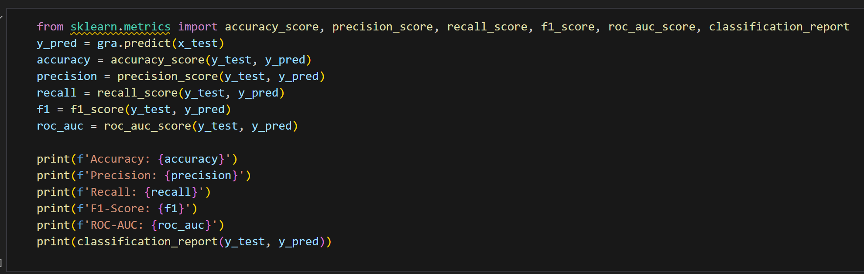

Logistic Regression

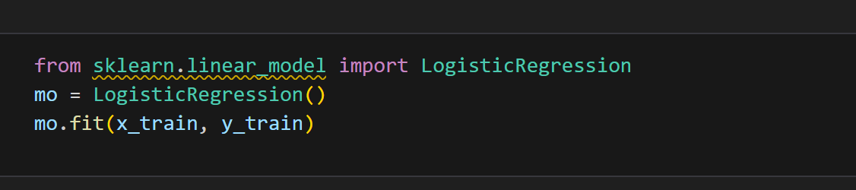

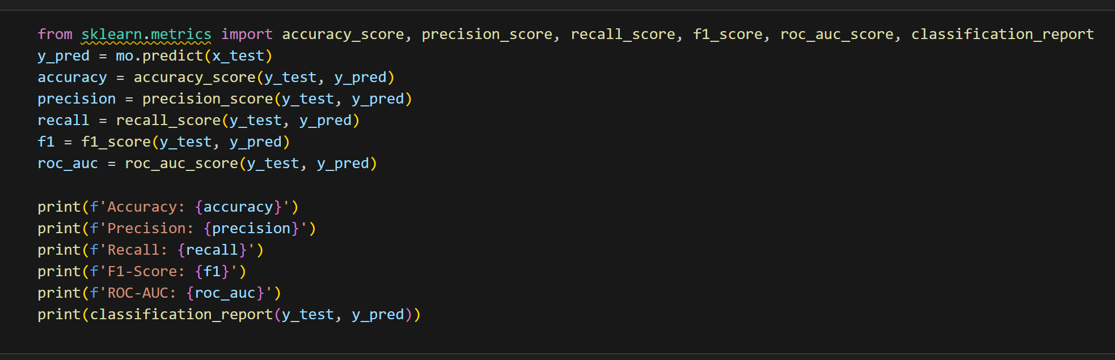

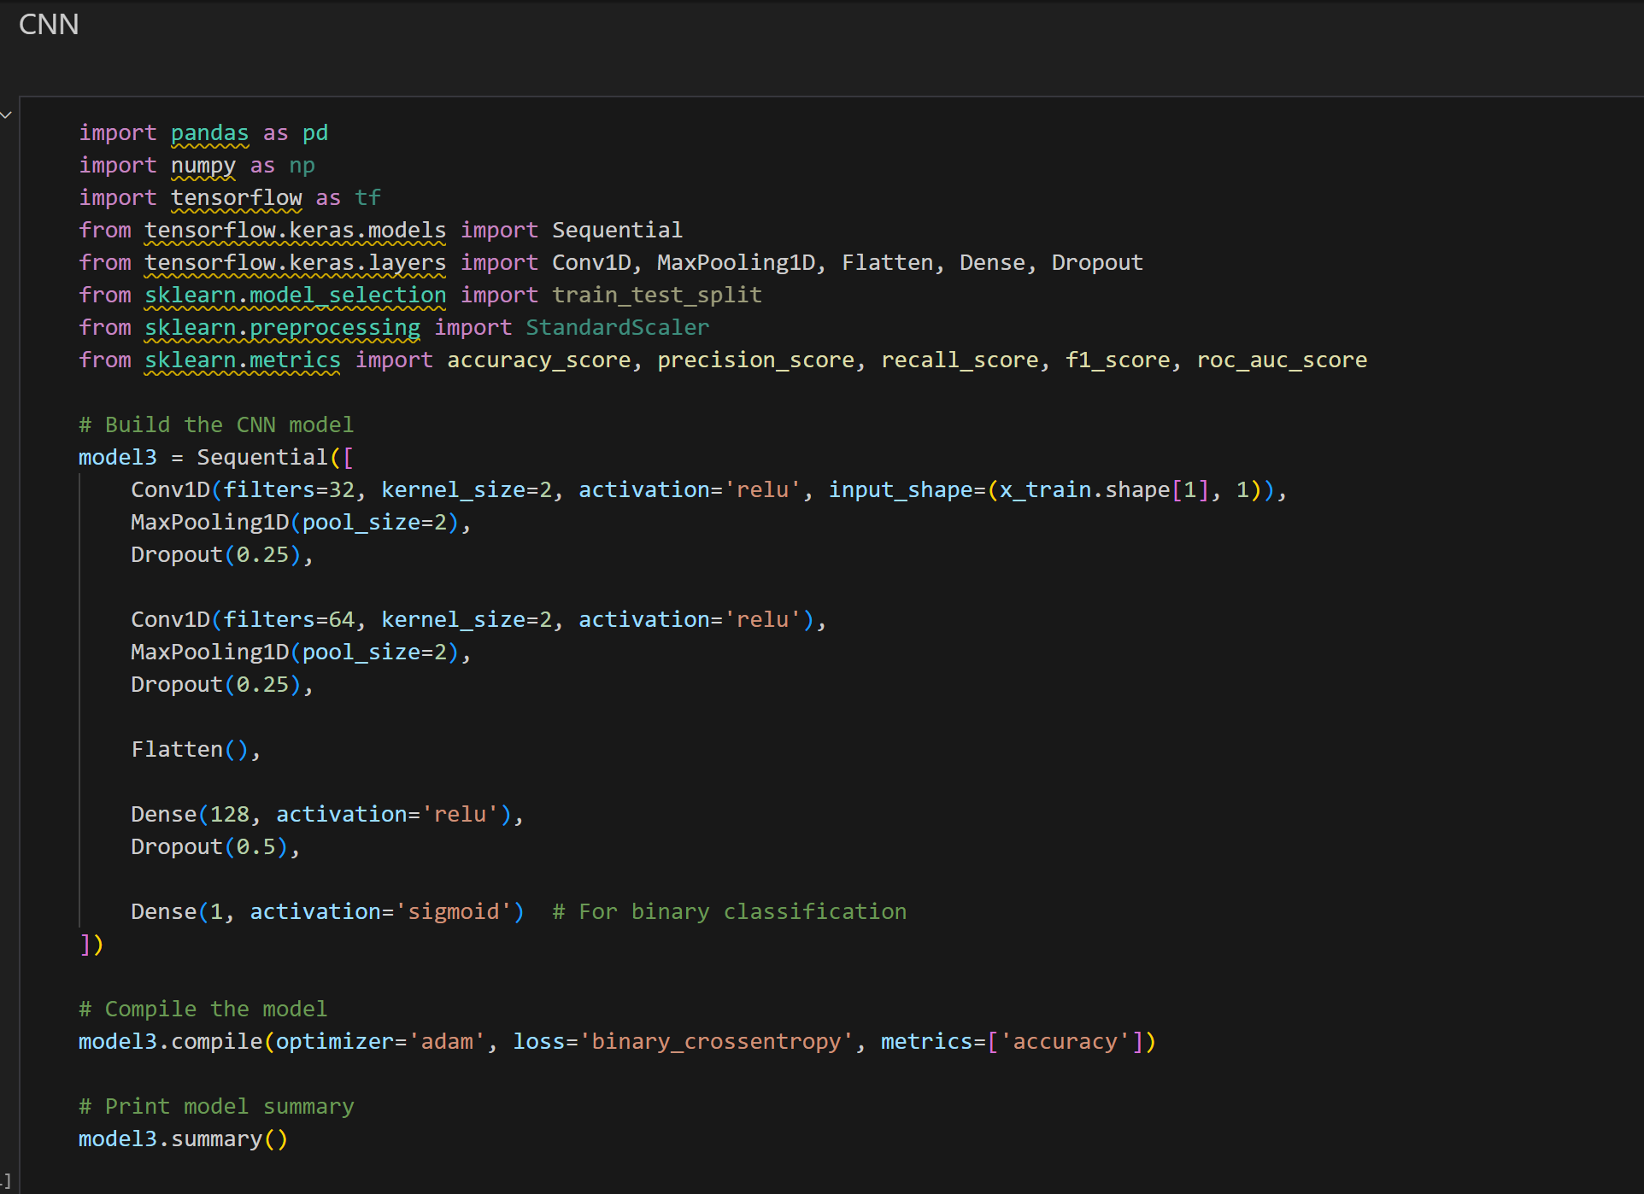

KNN

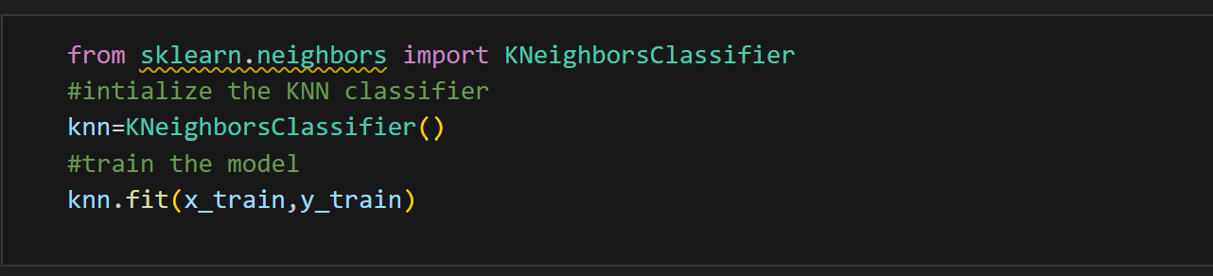

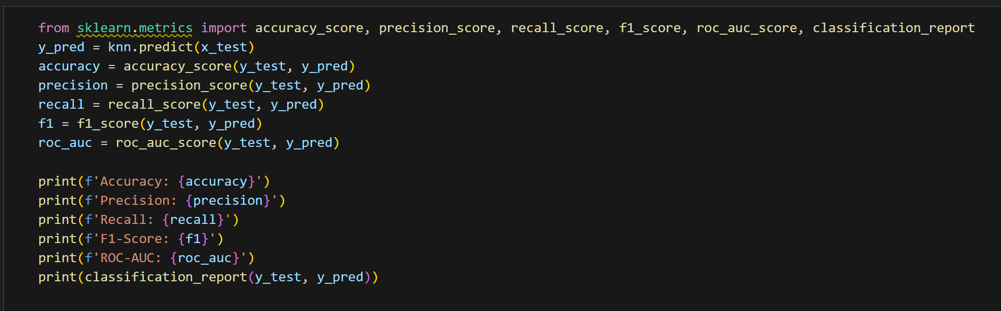

**Model Validation and Evaluation Report:**

|  |  |  |  |
| --- | --- | --- | --- |
| **Model** | **Classification Report** | **Accuracy** | **Confusion Matrix** |
| Ada Boost Classifier |  | 98.75% | Screenshot of the confusion matrix |
| Random Forest Classifier |  | 97.5% | Screenshot of the confusion matrix |
| Decision Tree Classifier |  | 95% | … |
| Gradient Boosting Classifier |  | 96.25% |  |
| XG Boost Classifier |  | 95% |  |
| Logistic Regression |  | 93.75% |  |
| K Neighbors Classifier |  | 88.75% |  |